**CUSTOMER RELATIONSHIP MANAGEMENT APP**

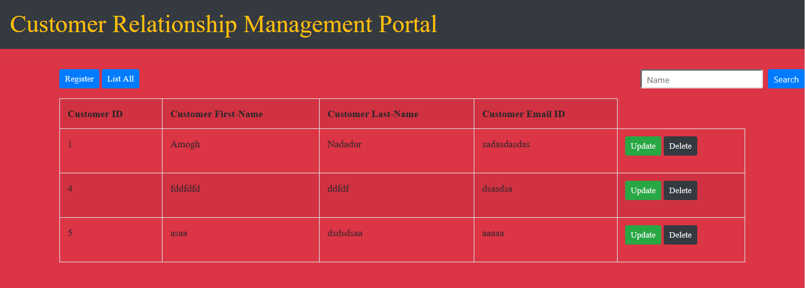

**CRUD OPERATIONS and OTHER OPERATIONS**

1. CREATE



1. READ



1. UPDATE

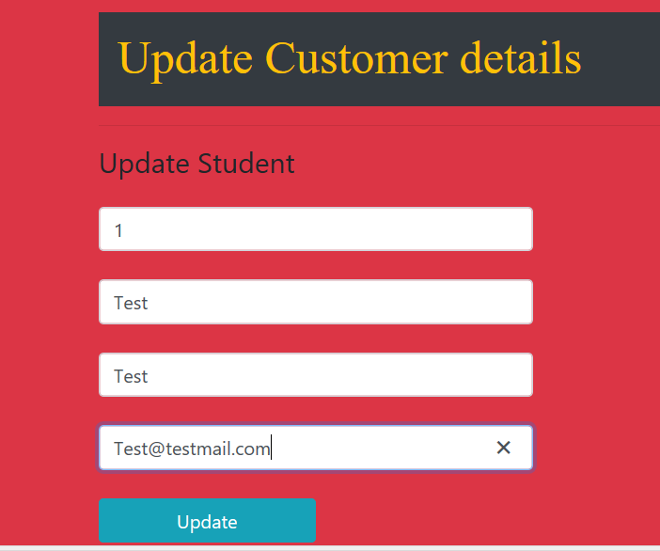

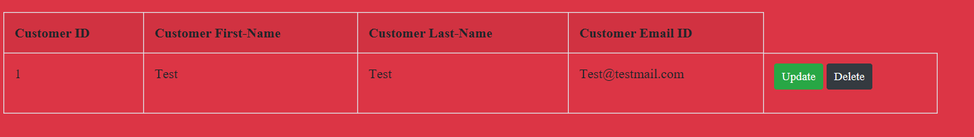

1. DELETE

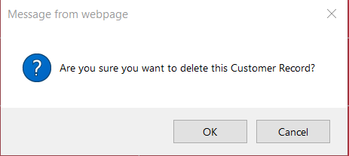

1. SEARCH



1. LIST ALL

